**Task 2: QA Telegram Bot Deployment Step**

There are a total of 3 steps that needs to be done to successfully run the program and the detailed steps can be found in the below sections:

1. Installation and running of COVIDASK System
2. Downloading Roberta-base-squad2 Deep Learning Model
3. Running of the Telegram Bot python file

This document will outline how to deploy and set-up the program files.

1. **Installation and running of COVIDASK System**

The first step is to download and install COVIDASK System from the git repository that can be found in the link here: <https://github.com/dmis-lab/covidAsk>.

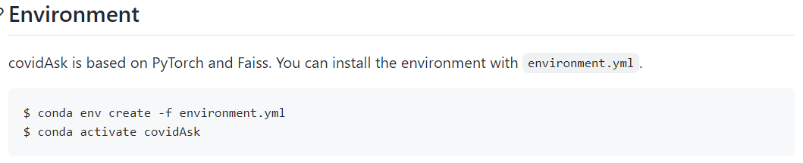

Under the “Environment” section of the github repository, covidAsk environment can be created and activated.

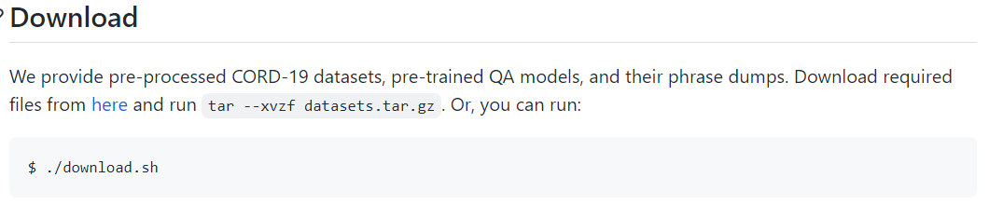

After creating and activating the covidAsk environment, proceed to download the pre-trained QA models under the “Downloads” section.

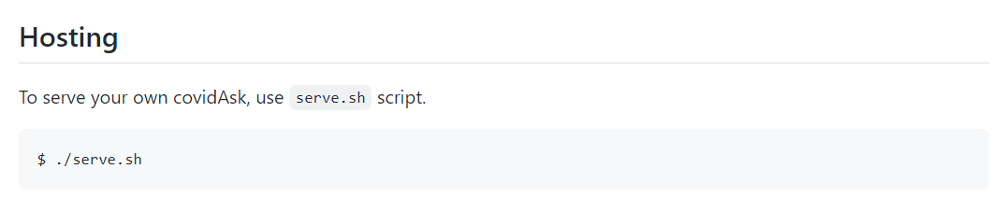

After downloading the required pre-trained QA models, the last step is to run the program using the serve.sh bash file as seen from the screenshot above.

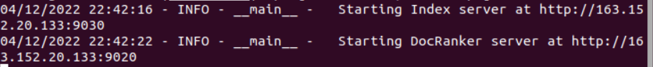

By following the instructions under the “Environment”, “Download” and “Hosting” section of the COVIDASK github, COVIDASK should be able to run successfully as shown on the screenshot above. Keep the COVIDASK program running throughout the whole process.

1. **Downloading Roberta-base-squad2 Deep Learning Model**

The next step after running the COVIDASK program is to ensure that the Roberta-base-squad2 Deep Learning Model files are downloaded and placed either inside the COVIDASK files, or somewhere within the same drive.

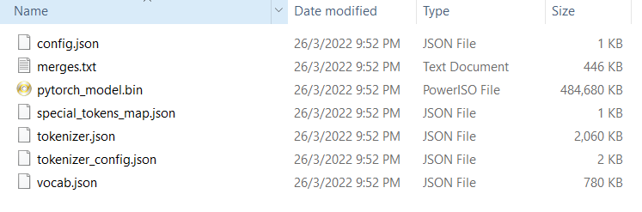

There are a total of 7 files inside the “model” folder and the “model” folder should be placed somewhere accessible or together with the COVIDASK FIles, depending on the user’s preference. Do be reminded to change and update the directory path in the telegram bot python files to where the “model” file resides. More will be explained in the next section.

1. **Running of the Telegram Bot python file**

After running the COVIDASK and downloading the Roberta-base-squad2 “model” file, the final step is to run the telegram bot python file named “TM_CovidQA_Telebot.py”.

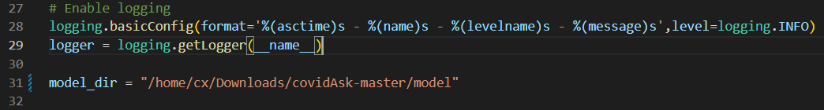

Similarly, the “TM_CovidQA_Telebot.py” file can be placed anywhere in the system, but ensure that the Roberta-base-squad2 model directory “model_dir” (line 31) is pointing to the correct directory where the model files downloaded from the previous section resides.



After ensuring that the COVIDASK program is running, Roberta-base-squad2 Deep Learning Model files downloaded and the “model_dir” path inside “TM_CovidQA_Telebot.py” (line 31) is updated correctly, the “TM_CovidQA_Telebot.py” should be able to run without any errors as shown in the screenshot above. Please note that both the “TM_CovidQA_Telebot.py” and COVIDASK program need to be running at all times when using the telegram bot.

**Checking If Program has Successfully Installed and Run**

Upon following all the steps above, proceed to the Telegram app and search for the Telegram Bot (@TM_CovidQA_Bot) either using the web or mobile app version.

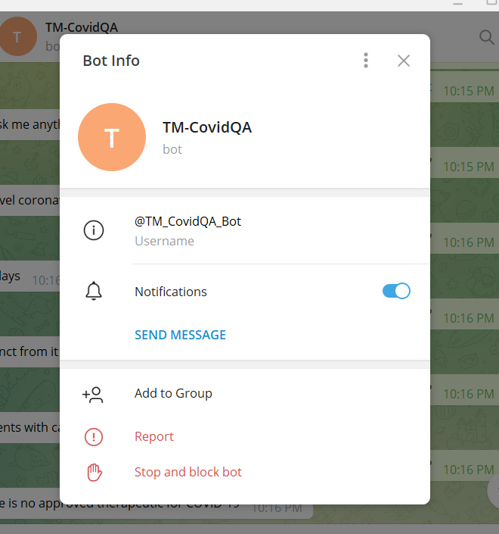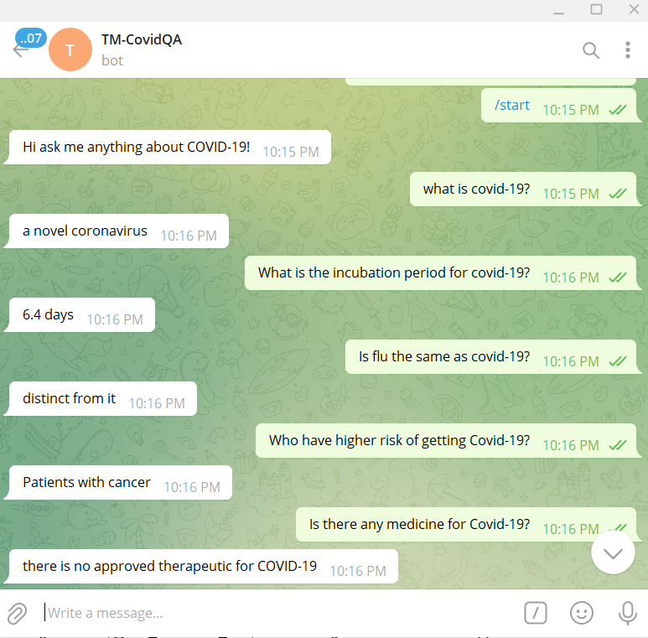

If all the above steps are done correctly, the bot should reply to all user query input as shown in the screenshot above.